**Purchase Order:**

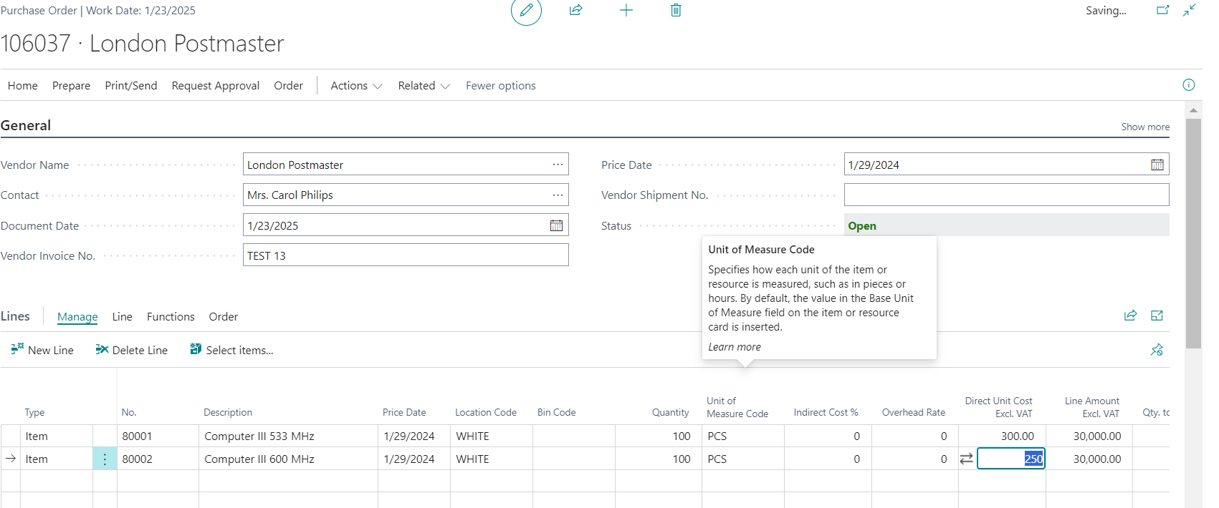

**Cost WorkSheet:**

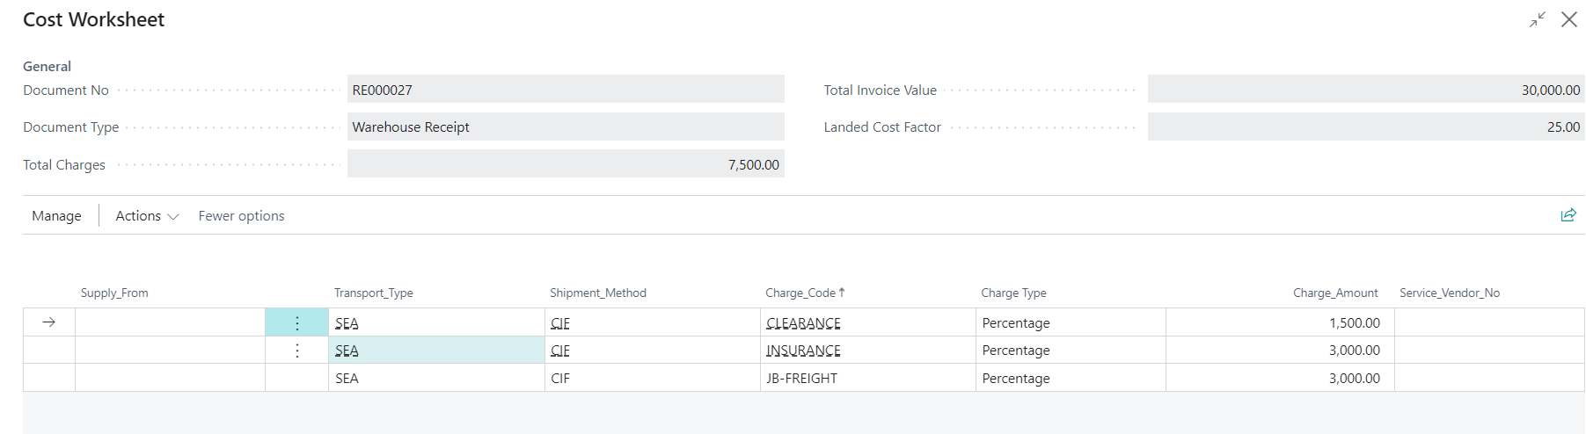

**WareHouse Receipt:**

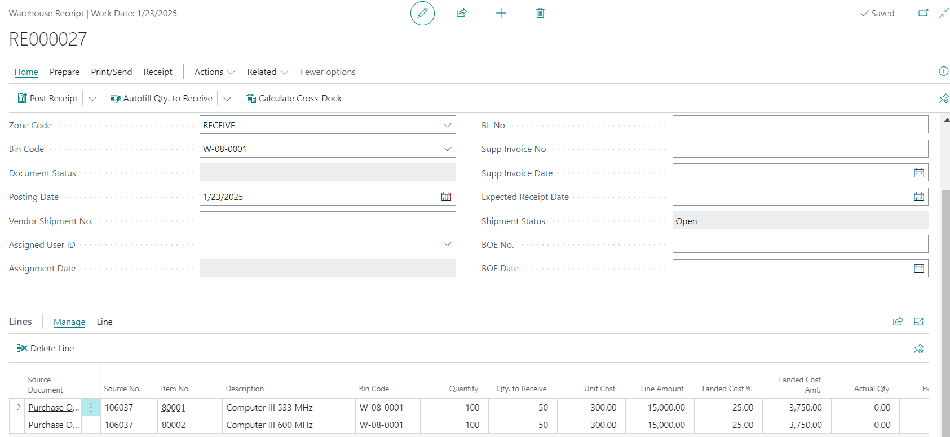

**Value Entries:**

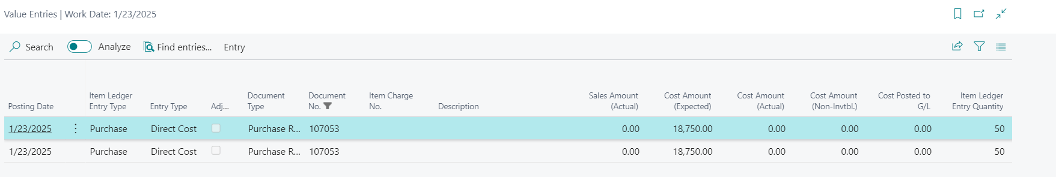

**Purchase Invoice:**

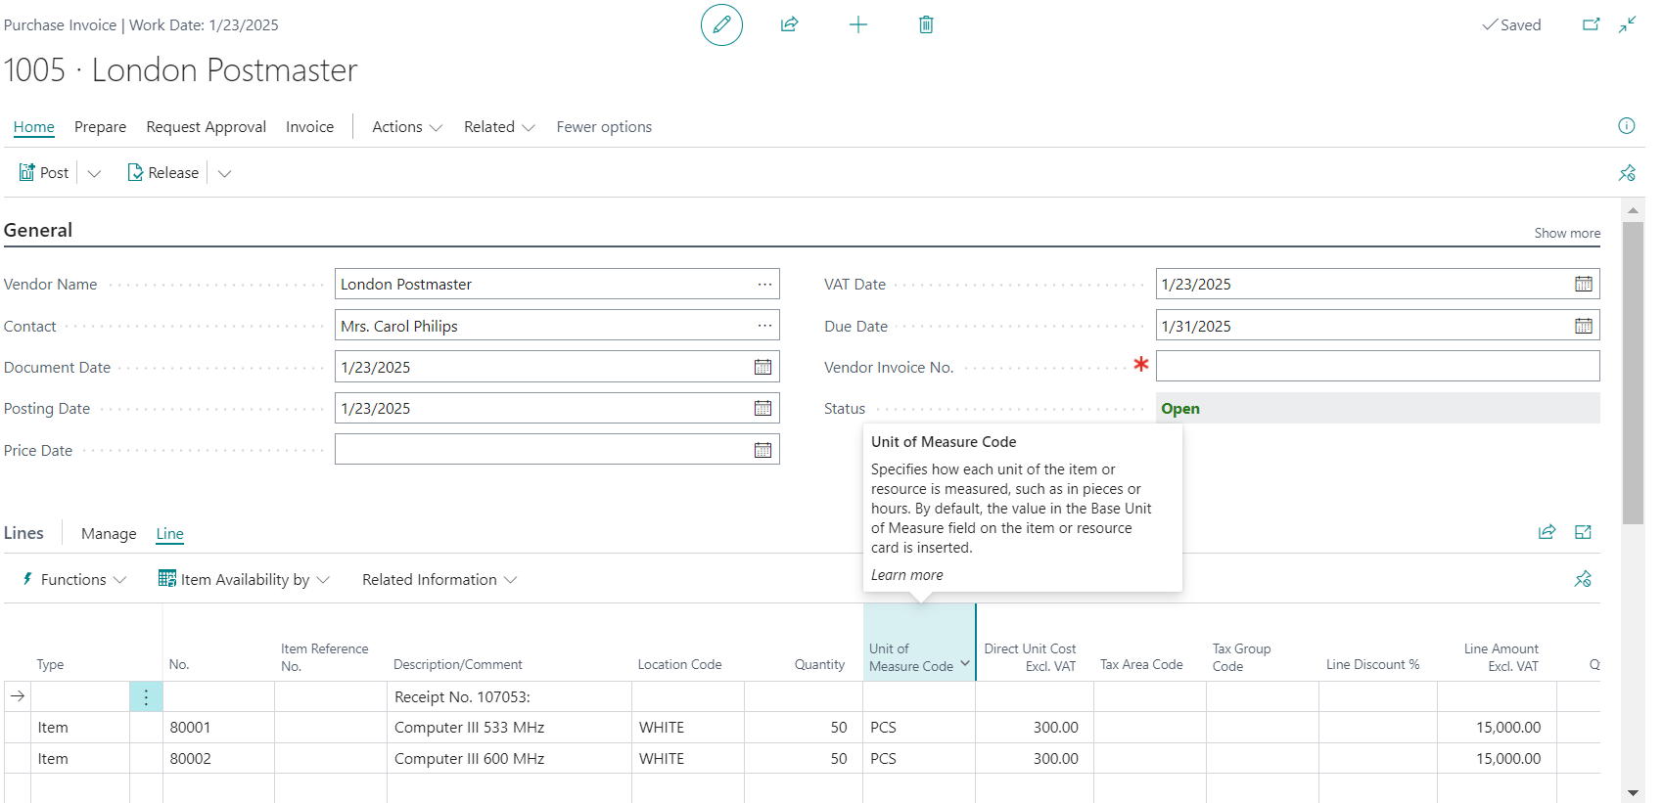

**After Purchase Invoice Posted: Value Entries**

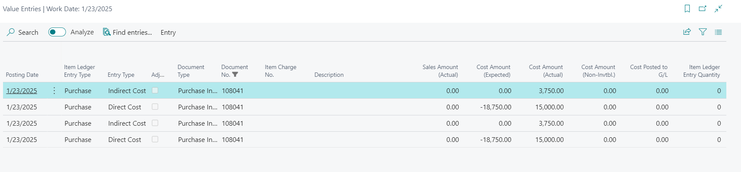

**GRN -2:**

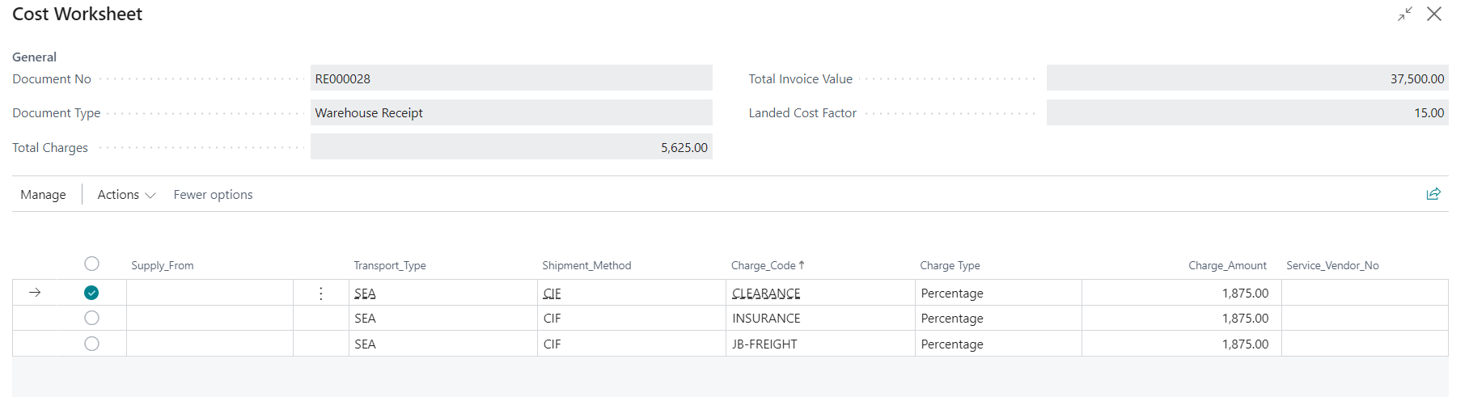

**Warehouse Receipt:**

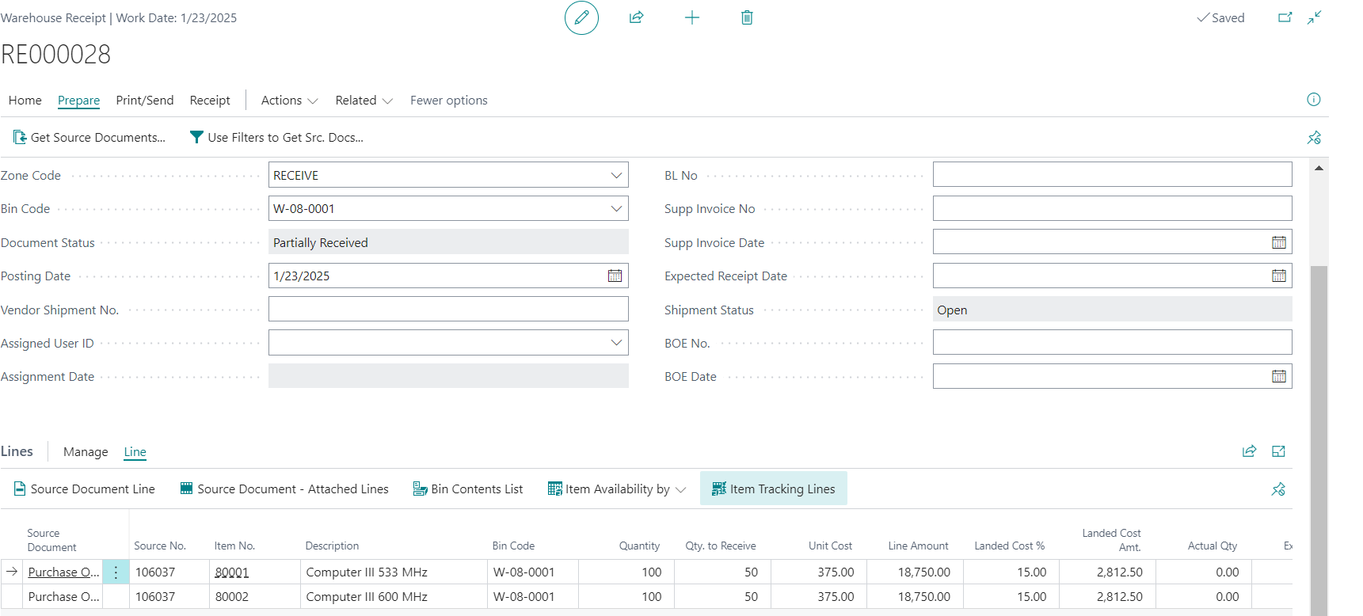

**Value Entries:**

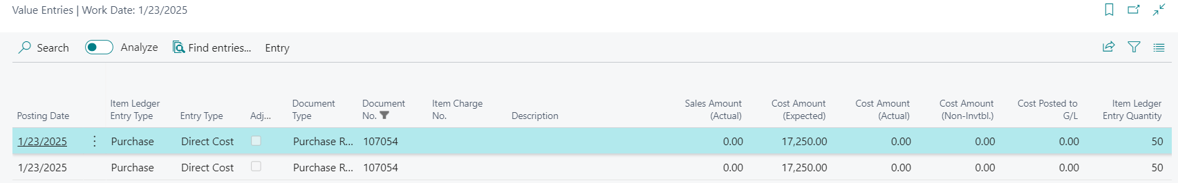

**Purchase Invoice:**

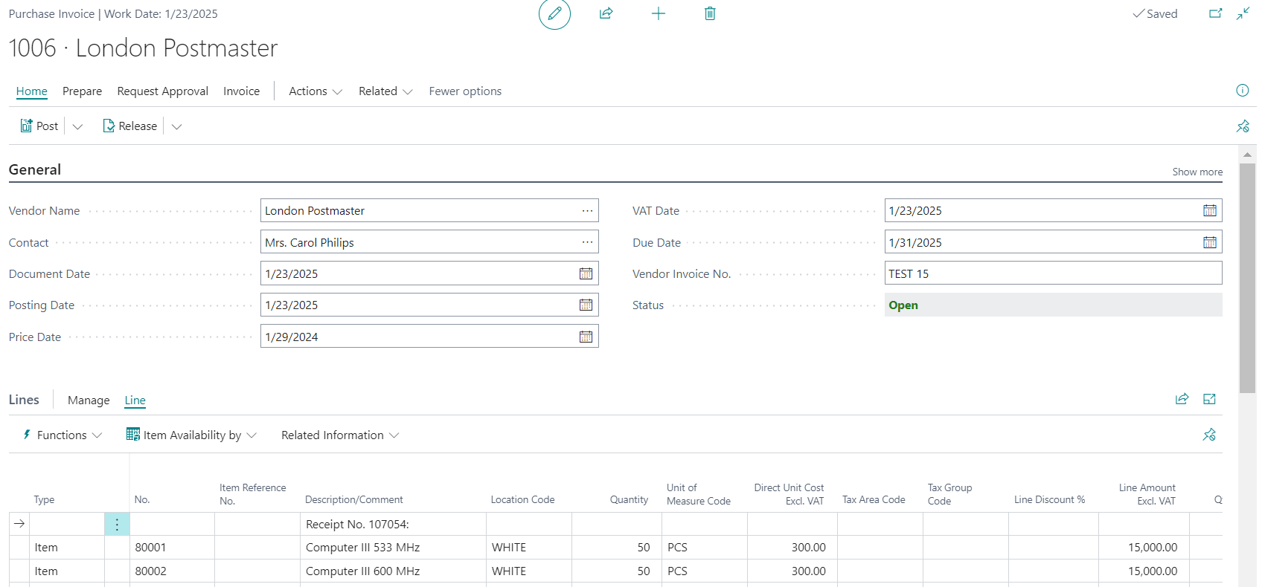

**After Purchase Invoice Posted: Value Entries**

